FOSSIL-Anomalocaris, Amplectobelua symbrachiata  
L. Cambrian, 525 Million years old  
Chengjiang, China

***Amplectobelua*** is an extinct genus of late [Cambrian](https://en.wikipedia.org/wiki/Cambrian) [anomalocaridid](https://en.wikipedia.org/wiki/Anomalocaridid), a group of stem [arthropods](https://en.wikipedia.org/wiki/Arthropods) that lived as free-swimming predators during the first half of the [Paleozoic Era](https://en.wikipedia.org/wiki/Paleozoic_Era). Like other anomalocaridids, *Amplectobelua* had a pair of jointed grasping appendages, large eyes, a limbless body, and a series of fins or swimming lobes on both sides that extended along the length of its body. It was smaller than the related [*Anomalocaris*](https://en.wikipedia.org/wiki/Anomalocaris), however, and had a specialized grasping appendage, in which the spine on the fourth segment hooked forward to oppose the tip of the appendage, allowing it to grasp prey like the pincer of a crab. The fins differ as well; the front fins are very long and slender, while the middle pair of tail fins are specialized into a pair of long streamers, or furci.

Two species are known, *Amplectobelua symbrachiata* from the [Chengjiang](https://en.wikipedia.org/wiki/Chengjiang) biota and *Amplectobelua stephenensis* from the later [Burgess Shale](https://en.wikipedia.org/wiki/Burgess_Shale).[[1]](https://en.wikipedia.org/wiki/Amplectobelua" \l "cite_note-Daley2010-1) *A. symbrachiata* is known from complete specimens, while *A. stephenensis* is known only from isolated claws. *A. stephenensis* is more advanced, with the pincer being more specialized for grasping: the fourth spine is larger and the spines on outer segments are reduced.

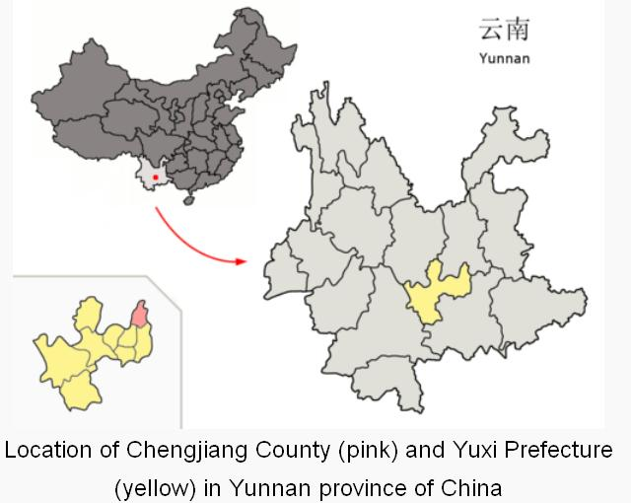

Chengjiang County is noted for soft-tissue fossil finds, of the [Maotianshan Shales](https://en.wikipedia.org/wiki/Maotianshan_Shales), dated to between 525 and 520 million years ago during the [Cambrian explosion](https://en.wikipedia.org/wiki/Cambrian_explosion), which "are as spectacular as the [Burgess Shale](https://en.wikipedia.org/wiki/Burgess_Shale) fauna, and significantly older." (Sterelny, Kim, 2007).

Amplectobelua is an anomalocaridid. Anomalocaridids have been variously regarded as basal stem-lineage euarthropods (e.g. Daley et al., 2009), basal members of the arthropod group Chelicerata (e.g. Chen et al., 2004), and as a sister group to the arthropods (e.g. Hou et al., 2006).

##### Species name: Amplectobelua stephenensis, from the Latin amplecto, “embrace,” and belua, “monster.” stephenensis – from Mount Stephen (3,199 m), the mountain peak in Yoho National Park from which the specimens were collected. Named in 1886 for George Stephen, the first president of the Canadian Pacific Railway. Other deposits: Amplectobelua symbrachiata from the Chengjiang Fauna in China. The Tulip Beds (S7) on Mount Stephen. Described by: Daley and Budd 2010; the Chengjiang specimens of Amplectobelua were first described as “anomalocaridid animal 2” in Chen et al. (1994) and given a formal designation as Amplectobelua symbrachiata by Hou et al. (1995).

##### The Burgess Shale genus Amplectobelua stephenensis was described by Daley and Budd (2010) from six specimens of isolated appendages in the Royal Ontario Museum collections.

##### 

##### Fig. 1 (left) and Fig. 2. bottom: Comparative sketches of anomalocaridid frontal appendages (presumed adult sizes) from the Burgess Shale (modified from Daley and Budd, 2010). A. Anomalocaris canadensis (modified from Briggs, 1979). B. Hurdia victoria appendage morph B (drawn from Daley et al. 2009). C. Hurdia victoria appendage morph A (drawn from Daley et al. 2009). D. Laggania cambria? E. Amplectobelua stephenensis. F. Caryosyntrips serratus. Scale bar = 10 mm. Fig. 2 (right, top).

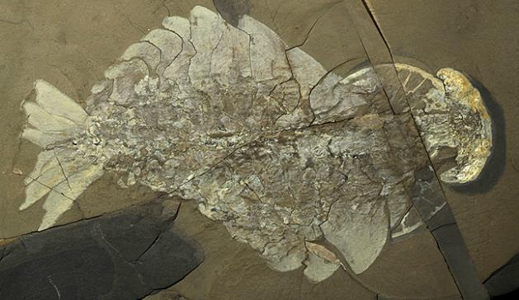 Anomalocaris canadensis (ROM 51211) Dorsal view, complete specimen showing the pair of eyes, claws, lobes and the posterior fan. Specimen length = 222 mm. Specimen wet – direct light. Raymond Quarry, Yoho National Park. Royal Ontario Museum. Photo: Jean-Bernard Caron

**History of Description Anomalocaris has a complex history of description because parts of its body were described in isolation before it was realized they all belonged to the same animal. The frontal appendage of Anomalocaris was described by Whiteaves (1892) as the body of a shrimp. The mouth parts were described by Walcott (1911) as a jellyfish called Peytoia nathorsti. A full body anomalocaridid specimen was originally described as the sea cucumber Laggania cambria (Walcott, 1911), and re-examined by Conway Morris (1978) who concluded it was a superimposition of the “jellyfish” Peytoia nathorsti on top of a sponge. Henriksen (1928) attached Anomalocaris to the carapace of Tuzoia, but Briggs (1979) suggested instead that it was the appendage of an unknown arthropod, an idea that turned out to be correct.**

**In the early 1980s, Harry Whittington was preparing an unidentified Burgess Shale fossil from the Geological Survey of Canada by chipping away layers of rock to reveal underlying structures, when he solved the mystery of Anomalocaris's identity. Much to his surprise, Whittington uncovered two Anomalocaris “shrimp” attached to the head region of a large body, which also had the “jellyfish” Peytoia as the mouth apparatus. Similar preparations of other fossils from the Smithsonian Institution in Washington, D.C., revealed the same general morphology, including the Laggania cambria specimen Conway Morris (1978) thought to be the superimposition of the Peytoia jellyfish on a sponge, which was actually a second species of Anomalocaris. Thus, Whittington and Briggs (1985) were able to describe two species: Anomalocaris canadensis, which had a pair of the typical Anomalocaris appendages, and Anomalocaris nathorsti, which has a different type of frontal appendage and includes the original specimen of Laggania cambria. Bergström (1986) re-examined the morphology and affinity of Anomalocaris and suggested it had similarities to the arthropods.**

##### 

##### Morphology: Amplectobelua stephenensis is known from isolated appendages that have twelve segments, with paired ventral spines on the second to ninth segments. The appendages range in size from 2.8 cm to 5.1 cm. The nearest podomere has a pair of large spines that extend most of the length of the whole appendage. There are also paired dorsal spines on the three furthest segments, which are long and curved towards the end of the appendage. No full-body specimens of A. stephenensis have yet been found, but it may have a similar morphology to A. symbrachiata and Anomalocaris, with wide swimming flaps on a dorsoventrally flattened body and a head with circular mouth parts and eyes on stalks (Chen et al., 1994). Maximum size: 51 mm

Amplectobelua is considered a predator, based on the morphology of its large eyes, frontal appendages with spines, gut glands, and spiny mouth apparatus. The circular mouth part is unique in the animal kingdom. It seems unlikely that it was used to bite prey by bringing lateral plates into opposition, rather, it grasped objects either by pivoting the plates outwards or contracting them inward. It has been suggested that Anomalocaris may have preyed on trilobites because some Cambrian trilobites have round or W-shaped healed wounds, interpreted as bite marks (Rudkin, 1979), and large fecal pellets composed of trilobite parts have been found in the Cambrian rock record; anamalocaridids are the only known animals large enough to have produced such pellets. The anomalocaridids could have fed by grasping one end of the trilobite in the mouth apparatus and rocking the other end back and forth with the frontal appendages until the exoskeleton cracked (Nedin, 1999). However, the unmineralized mouth apparatus of Anomalocaris would have probably been too weak to penetrate the calcified shell of trilobites in this manner, and the mouth parts do not show any sign of breakage or wear. Thus, Anomalocaris may have been feeding on soft-bodied organisms including on freshly moulted "soft-shell" trilobites (Rudkin, 2009).

The Anomalocaris frontal appendage is extremely common at the Mount Stephen Trilobite Beds, and several hundred specimens of isolated frontal appendages and mouth parts have been collected from Mount Stephen and the Raymond Quarry on Fossil Ridge. These parts are relatively rare at Walcott Quarry, where fewer than 50 specimens are known (Caron and Jackson, 2008). Several dozen disarticulated assemblages and five complete body specimens are known from the Raymond Quarry.

##### References

BERGSTRÖM, J. 1986. Opabinia and Anomalocaris, unique Cambrian 'arthropods'. Lethaia, 19: 241-46.

BRIGGS, D. E. G. 1979. Anomalocaris, the largest known Cambrian arthropod. Palaeontology, 22: 631-663.

CARON, J.-B. AND D. A. JACKSON. 2008. Paleoecology of the Greater Phyllopod Bed community, Burgess Shale. Palaeogeography, Palaeoclimatology, Palaeoecology, 258: 222-256.

CHEN, J. Y., D. WALOSZEK AND A. MAAS. 2004. A new "great-appendage" arthropod from the Lower Cambrian of China and homology of chelicerate chelicerae and raptorial antero-ventral appendages. Lethaia, 37: 3-20.

CHEN, J. Y., L. RAMSKÖLD AND G. Q. ZHOU. 1994. Evidence for monophyly and arthropod affinity of Cambrian giant predators. Science, 264: 1304-1308.

DALEY, A. C., G. E. BUDD, J.-B. CARON, G. D. EDGECOMBE AND D. COLLINS. 2009. The Burgess Shale anomalocaridid Hurdia and its significance for early euarthropod evolution. Science, 323: 1597-1600.

DALEY, A. C. AND G. E. BUDD. 2010. New anomalocaridid appendages from the Burgess Shale, Canada. Palaeontology, 53: 721-738

COLLINS, D. 1996. The "evolution" of Anomalocaris and its classification in the arthropod class Dinocarida (nov) and order Radiodonta (nov). Journal of Paleontology, 70: 280-293.

CONWAY MORRIS, S. 1978. Laggania cambria Walcott: a composite fossil. Journal of Paleontology, 52: 126-131.

DALEY, A. C., G. E. BUDD, J. B. CARON, G. D. EDGECOMBE AND D. COLLINS. 2009. The Burgess Shale anomalocaridid Hurdia and its significance for early euarthropod evolution. Science, 323: 1597-1600.

HENRIKSEN, K. L. 1928. Critical notes upon some Cambrian arthropods described from Charles D. Walcott. Videnskabelige Meddelelser fra Dansk Naturhistorisk Forening: Khobenhavn, 86: 1-20.

HOU, X., J. BERGSTRÖM AND P. AHLBERG. 1995. Anomalocaris and other large animals in the Lower Cambrian Chengjiang fauna of Southwest China. GFF, 117: 163-183.

HOU, X., J. BERGSTRÖM AND Y. JIE. 2006. Distinguishing anomalocaridids from arthropods and priapulids. Geological Journal, 41: 259-269.

# Xian-guag Hou, Richard Aldridge, Jan Bergstrom, David J. Siveter, [Derek Siveter](http://www.amazon.com/s/ref=dp_byline_sr_book_5?ie=UTF8&text=Derek+Siveter&search-alias=books&field-author=Derek+Siveter&sort=relevancerank), [Xiang-Hong Feng](http://www.amazon.com/s/ref=dp_byline_sr_book_6?ie=UTF8&text=Xiang-Hong+Feng&search-alias=books&field-author=Xiang-Hong+Feng&sort=relevancerank). 2007. The Cambrian Fossils of Chengjiang, China: The Flowering of Early Animal Life. New York: Wiley-Blackwell.

NEDIN, C. 1999. Anomalocaris predation on nonmineralized and mineralized trilobites. Geology, 27: 987-990.

RESSER, C. E. 1929. New Lower and Middle Cambrian Crustacea. Proceedings of the United States National Museum, 76: 1-18.

RUDKIN, D. M. 1979. Healed injuries in Ogygosis klotzi (Trilobita) from the Middle Cambrian of British Columbia. Royal Ontario Museum, Life Sciences Occasional Paper, 32: 1-8.

RUDKIN, D. M. 2009. The Mount Stephen Trilobite Beds, pp. 90-102. In J.-B. Caron and D. Rudkin (eds.), A Burgess Shale Primer – History, Geology, and Research Highlights. The Burgess Shale Consortium, Toronto.

[Sterelny, Kim](https://en.wikipedia.org/wiki/Kim_Sterelny) (2007). Dawkins Vs Gould: Survival of the Fittest. Cambridge, U.K.: Icon Books. p. 116.

USAMI, Y. 2006. Theoretical study on the body form and swimming pattern of Anomalocaris based on hydrodynamic simulation. Journal of Theoretical Biology, 238: 11-17.

WALCOTT, C. D. 1911. Middle Cambrian holothurians and medusae. Cambrian geoogy and paleontology II. Smithsonian Miscellaneous Collections, 57: 41-68.

WHITEAVES, J. F. 1892. Description of a new genus and species of phyllocarid Crustacea from the Middle Cambrian of Mount Stephen, B.C. Canadian Record of Science, 5: 205-208.

WHITTINGTON, H. B. AND D. E. G. BRIGGS. 1985. The largest Cambrian animal, Anomalocaris, Burgess Shale, British-Columbia. Philosophical Transactions of the Royal Society of London Series B-Biological Sciences, 309: 569-609.

## External links

[*"Amplectobelua stephenensis"*](http://burgess-shale.rom.on.ca/en/fossil-gallery/view-species.php?id=21). Burgess Shale Fossil Gallery. Virtual Museum of Canada. 2011.

* [Anomalocaris Homepage](http://www.trilobites.info/anohome.html)